THEORY QUESTIONS
1.
(a)

Study the image carefully and use it to answer questions (a)(i-ii) and (b).
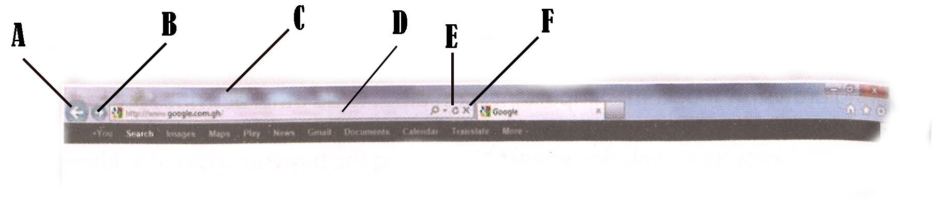
(i)

What is the name of the image shown above?
(ii)

Name the parts of the image represented by A, B, C, D, E and F in (a)
(b)

State the function of the parts labelled A and D in (a) above;
(c)

List four uses of the internet.
(d)

Write the name of the following computer keyboard key characters:
(i)

&
(ii)

^
(iii)

{}
(iv)

/

2.
(a)

Give the functions of the following keyboard keys:
(i)

Backspace
(ii)

Space bar
(b)

(i)

Outline three differences between selecting and highlighting text in a Word Processing application.
(ii)

Name two word processors.

3.
(a)

State the two types of storage media.
(b)

(i)

Give three important features of storage media.
(ii)

State two ways to protect storage.

4.
(a)

What is:
(i)

application software;
(ii)

system software
(iii)

a folder
(b)

Give three examples of an operating system.

5.
(a)

List three toolbars or bars in a spreadsheet application.
(b)

Define the following terms as used in a spreadsheet application:
(i)

cell;
(ii)

active cell;
(iii)

name box.

